Loncept Map Student Name: Instructor:

Erickson's Develo(!mental Stai:e Related to (!t. & Cite References m

Histon: of Present Illntss!'.!If!}, Patbo(!by!iol!!C of Admittioi: Dx
{Cite References) Medical, Surgical, Social Histon:
m.

Patient Education {In Pt.) & DiscbalJ!e Plannioi: (home needs)

Medical Riston:

Sun!ical Riston:

l u•tura-• consm,.ri Hons etbntc•"'· octlfllaHod renomn. family SU(!IIOrt. Insurance, (1) {14)
I
Social Histon:

atient Information
Dlai:nostlc Test/ Lab Results with dates (1)
and Normal Raai:es (3) Name:
Age:
Gender:
>
Test Norms Date Current Code Status:
Value DPOA:
Living Will:
CbiefCom(!laiut -

Admittini: Diai:nosis

I

Medical Maaai:emen1.( Orders/ Medications & Allen!ies (2)

Name
Dose RT
Freq.
MOA
RN
Considerations
Onset/Peak/ Duration Clnsulin)

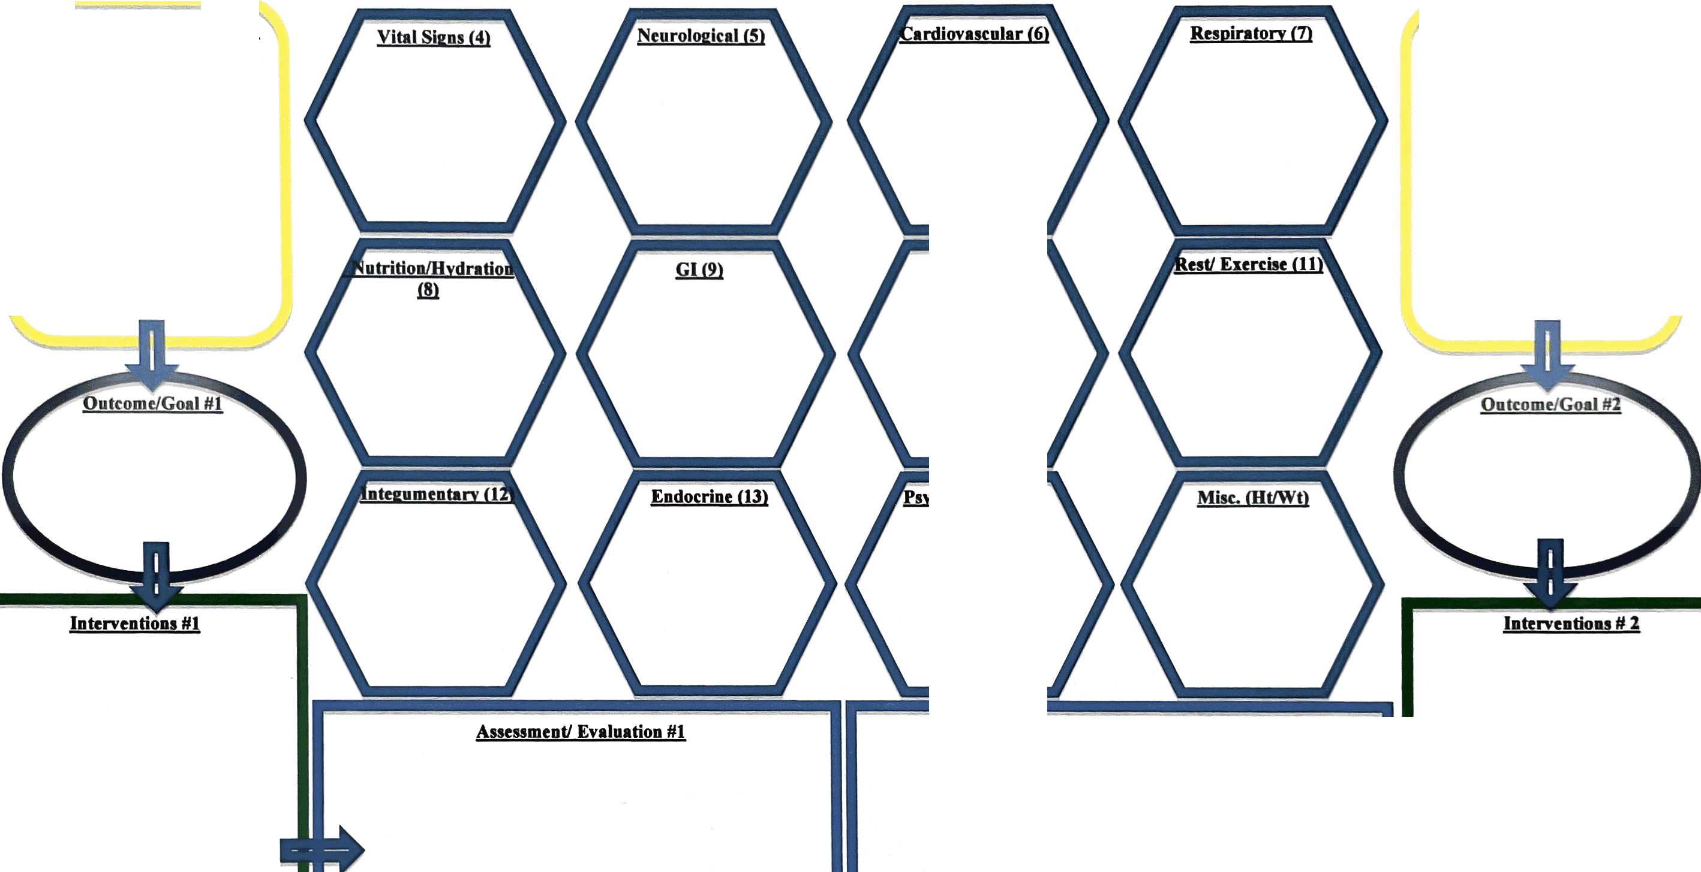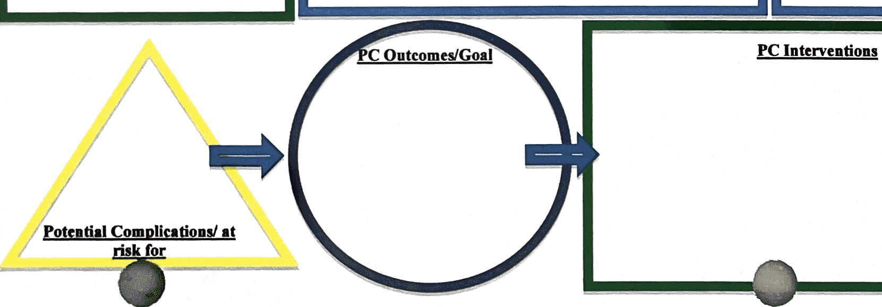Priority nuning diagnosis #1 'Pri ority nuning diagnll!is #2

GUUO)

'sycbosoclal (14

Assessment/ Evaluation #2

"'ll!I

PC Evaluation Plan

Chief Complaint:

"swelling of tongue and difficulty breathing and swallowing" History of Present Illness:
59 y o woman in NAD with a h/o CAD, DM2, asthma and HTN on altace for 8 years awoke from sleep around 2:30 am this morning of a sore throat and swelling of tongue. She came immediately to the ED b/c she was having difficulty swallowing and some trouble breathing due to obstruction caused by the swelling. She has never had a similar reaction ever before and she did not have any associated SOB, chest pain, itching, or nausea. She has not noticed any rashes, and has been afebrile. She says that she feels like it is swollen down in her esophagus as well. In the ED she was given 25mg benadryl IV, 125 mg solumedrol IV and pepcid 20 mg IV. This has helped the swelling some but her throat still hurts and it hurts to swallow. Nothing else was able to relieve the pain and nothing make it worse though she has not tried to drink any fluids because of trouble swallowing. She denies any recent travel, recent exposure to unusual plants or animals or other allergens. She has not started any new medications, has not used any new lotions or perfumes and has not eaten any unusual foods. Patient has not taken any of her oral medications today.
Surgical History:

s/p Cardiac stent in 1999 s/p hysterectomy in 1970s s/p appendectomy 1960s Medical History:
+CAD w/ Left heart cath in 2005 showing 40% LAD, 50% small D2, 40% RCA and 30% large OM; 2006 TTE showing LVEF 60-65% with diastolic dysfunction, LVH, mild LA dilation
+Hyperlipidemia

+HTN

+DM 2, last Ale 6.7 in 9/2019

+Asthma/CO PD

+GERO

+h/o iron deficiency anemia

Social History: Patient lives at home with 27 yo daughter . Patient does all ADLs and ADLs with no/little assistance. She does own finances and drives. Patient has 4 daughters that all live in the area. Patient does not use tobacco, alcohol, illicit drugs. Pts parents were Baptist pastors. She finished high school married her high school sweet heart. Was a stay home mom. Loves to bake. Pt has been a widow for 15 yrs. Belong to Librarian and flower arrangement club

Family History:
•

Patient's Dad died of heart attach at age 59, mom died of heart attack at age 60. She has 4 siblings who most died of cardiac disease. There is no family history of cancer.
Allergies:

Penicillin- respiratory distress Cipro - rash
Benadryl - causes mild dystonic reaction Medications:
Theophyline (Uniphyl) 600 mg qhs - bronchodilator by increasing cAMP used for treating asthma
Diltiazem 300 mg qhs - Ca channel blocker used to control hypertension

Simvistatin (Zocor) 20 mg qhs- HMGCo Reductase inhibitor for hypercholesterolemia Ramipril (Altace) 10 mg BID -ACEI for hypertension and diabetes for renal protective effect
Glipizide S mg BID (diabetes) - sulfonylurea for treatment of diabetes

Omecprazole (Prilosec) 20 mg daily (reflux) - PPI for treatment of ulcers

Gabapentin (Neurontin) 100 mg qhs - modulates release of neurotransmitters to treat diabetic neuropathy
Metformin 500 mg qam - biguanide used to treat diabetes Aspirin 81 mg qam - prophylaxis for Ml and TIA
Servant lpuff bid-

Fluticasone (Flovent) 2 puff bid - corticosteroid to treat airways in asthma/copd

xoperex 1.25mg and lpratropium 2.5 ml nebulized qam - anticholinergic to treat airways in COPD
Review of Systems:

Constitutional - NAD, has been generally feeling well the last couple of weeks Eyes - no changes in vision, double vision, blurry vision, wears glasses
ENT - No congestion, changes in hearing, does not wear hearing aids

Skin/Breast - no rashes

Cardiovascular - No SOB, chest pain, heart palpitations

Pulmonary - hard to get a breath in but not short of breath, no cough Endocrine - No changes in appetite
Gastro Intestinal - No n/v/d or constipation. Has not eaten because can't swallow solid foods.
Genito Urinary - No increased frequency or pain on urination. Some urge incontinence with history of prolapse.
Musculo Skeletal - no changes in strengths, no joint tenderness or swelling Neurologic - No changes in memory
Psychology - No changes in mood Heme/Lymph - Denies easy bruising Physical Examination:
Vitals:

Temp 35.9

Pulse 76

02 98% RA

RR 20

BP 159/111

General - NAO, sitting up in bed, well groomed and in nightgown Eyes - PERRLA, EOM intact
ENT - Large swollen tounge and cheek on left side, tounge was large and obscured the view of the posterior oropharynx
Neck - No noticeable or palpable swelling, redness or rash around throat or on face Lymph Nodes - No lymphadenopathy
Cardiovascular - RRR no m/r/g, no JVD, no carotid bruits

Lungs - Clear to auscltation, no use of acessory muscles, no crackles or wheezes. Skin - No rashes, skin warm and dry, no erythematous areas
- Breast-

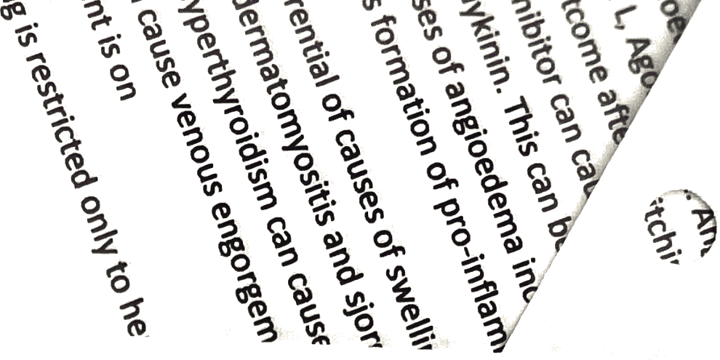

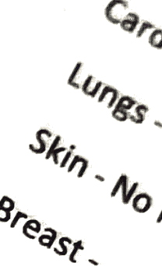
Psychiatry -

Abdomen - Normal bowel sounds, abdomen soft and nontender

Genito Urinary- Genital exam not performed since complaints not related. Rectal - Rectal exam not performed since no symptoms indicated blood loss. Extremeties - No edema, cyanosis or clubbing
Musculo Skeletal - 5/5 strength, normal range of motion, no swollen or erythematous joints.
Neurological-Alert and oriented x 3, CN 2-12 grossly intact. Pertinent Diagnostic Tests:
Na 140 K4.5 Cl109 Co2 23
BUN 29

Cr 1.0

Ca 9.9

Mg 1.4

Phos 3.6

PTT 26.7 WBC9.9 Hgb 10.0
Hct 30.3

Pit 373

Plan:

++Swollen tongue:

- Give patient corticosteroid to decrease inflammation and to protect against relapse aft er init ial improvement. 4 days of Dexamethasone 10 mg IV tid.
- Give patient antihistamine to block inflammation as well . 4 days of Diphenhydramine 25 mg bid.

- ENT consult to rule out abscess or foreign object

- Check Cl and C4 levels that would be decreased if the patient had Cl inhibitory complement defi ciency

- TSH level to check for hypo/hyper thyroid

- Hold all oral home meds and keep patient NPO until airway swelling is reduced and patient can swallow easily
++Asthma/COPD

continue albuterol and iprat ropi um nebs prn

- resume theophylline when pati ent can take oral meds
++DM

- Not on oral home meds

- Patient is on corticosteroids that increase blood glucose levels, so put pat ient on sli ding scale normal insulin to adjust for high sugars
- Resume neurontin for neuropathy when oral meds can be taken

++HTN


- Continue patient' s BP control with Diltiazem drip Smg/hour


- HOW alta ce (ACEI) that is most likely the cause of angioedema

- Con sider an alt ernati ve HTN medication to rep lace the ACEI. Can't use a HCTZ because of sulfa aller g.y Also has asthma/COPD picture so beta blocker may not work well either.
++CAD s/p PCI in 1999

- Resume simvastatin and aspirin when patient is able to take oral meds

++GERD

- famotidine when oral meds are resumed

•



Chief Complaint:

"swelling of tongue and difficulty breathing and swallowing" History of Present Illness:
59 yo woman in NAD with a h/o CAD, DM2, asthma and HTN on altace for 8 years awoke from sleep around 2:30 am this morning of a sore throat and swelling of tongue. She came immediat ely to t he ED b/c she was having difficulty swallowing and some trouble breathing due to obstruction caused by the swelling. She has never had a similar reaction ever before and she did not have any associated SOB, chest pain, itching, or nausea. She has not noticed any rashes, and has been afebrile. She says that she feels like it is swollen down in her esophagus as well. In the ED she was given 25mg benadryl IV, 125 mg solumedrol IV and pepcid 20 mg IV. This has helped the swelling some but her throat still hurts and it hurts to swallow . Nothing else was able to relieve the pain and nothing make it worse though she has not tried to drink any fluids because of trouble swallowing. She denies any recent travel, recent exposure to unusual plants or animals or other allergens. She has not started any new medications, has not used any new lotions or perfumes and has not eaten any unusual foods. Patient has not taken any of her oral medications today.
Surgical History:

s/p Cardiac stent in 1999 s/p hysterectomy in 1970s s/p appendectomy 1960s Medical History:
+CAD w/ Left heart cath in 2005 showing 40% LAD, 50% small D2, 40% RCA and 30% large OM; 2006 TTE showing LVEF 60-65% with diastolic dysfunction, LVH, mild LA dilation
+Hyperlipidemia

+HTN

+DM 2, last Ale 6.7 in 9/2019

+Asthma/CO PD

+GERO

+h/o iron deficiency anemia

Social History: Patient lives at home with 27 yo daughter . Patient does all ADLs and ADLs with no/little assistance. She does own finances and drives. Patient has 4 daughters that all live in the area. Patient does not use tobacco, alcohol, illicit drugs. Pts parents were Baptist pastors. She finished high school married her high school sweet heart. Was a stay home mom. Loves to bake . Pt has been a widow for 15 yrs. Belong to Librarian and flower arrangement club

...

